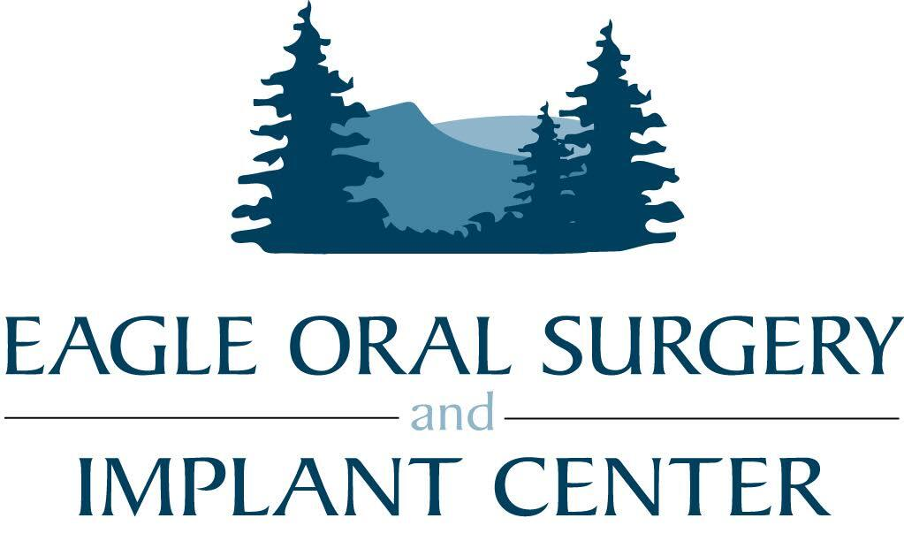

NOTICE OF PRIVACY PRACTICES
Eagle Oral Surgery
Dr. Jeremy Hixson, DMD
Effective Date: June 18th 2026
THIS NOTICE DESCRIBES HOW MEDICAL INFORMATION ABOUT YOU MAY BE USED AND DISCLOSED AND HOW YOU CAN ACCESS THIS INFORMATION. PLEASE REVIEW IT CAREFULLY.

How We May Use and Disclose Your Health Information
Treatment: We may use and share your health information with other healthcare professionals involved in your care.
Payment: We may use and disclose your health information to obtain payment for services provided and submit insurance claims.
Healthcare Operations: We may use your information for quality assessment, staff training, compliance activities, and business management.
Appointment Reminders and Treatment Information: We may contact you regarding appointments, treatment recommendations, and follow-up care.
Individuals Involved in Your Care: We may share relevant information with family members or caregivers involved in your care unless you object.
As Required by Law: We may disclose your information when required by law.
Public Health and Safety: We may disclose information for public health and safety purposes.
Law Enforcement and Legal Proceedings: We may disclose information in response to lawful legal processes.
Workers' Compensation: We may disclose information as authorized by workers' compensation laws.
Research: Information may be used or disclosed for approved research activities as permitted by law.
Other Uses and Disclosures: Any other use or disclosure requires your written authorization.

Your Rights Regarding Your Health Information
Inspect and Obtain Copies: You may request access to and copies of your medical and billing records.
Request Amendments: You may request corrections to your records.
Request Restrictions: You may ask us to limit certain uses or disclosures.
Confidential Communications: You may request communications in a specific manner or location.
Receive an Accounting of Disclosures: You may request a list of certain disclosures.
Obtain a Paper Copy: You may request a paper copy of this notice.
Breach Notification: You will be notified of qualifying breaches of unsecured protected health information.

Questions or Complaints
Privacy Officer
Eagle Oral Surgery
Phone: 208-995-2865
Email: manager@Eagleoralsurgery.com
Address: 197 W State Street, Eagle, Idaho 83616

Acknowledgment of Receipt of Notice of Privacy Practices
I acknowledge that I have received or been offered a copy of Eagle Oral Surgery's Notice of Privacy Practices.
Patient Name: ___________________________________
Patient Signature: ________________________________
Date: ___________________________________________
If signed by personal representative:
Name: __________________________________________
Relationship to Patient: ___________________________

